Personal Project Manual

G-28 Console Custom rPi Games Console Manual

Hackspace Module

2019-2020

Georgina Hill
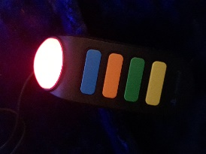
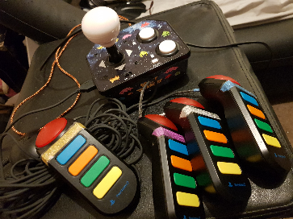
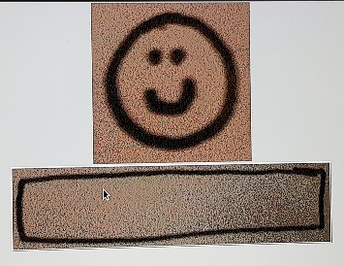

G-28 Console Manual

imagery here
Some modes can only be controlled with the Buzz Controllers.
Important Disclaimer:
If you experience any sort of discomfort when using this application, please consult with a doctor or your GP before continuing to use the Raspberry Pi console.
Hardware Requirements:
- Monitor with HDMI port*
- Raspberry Pi custom games console unit
- PlayStation 2 Buzz Controllers
- Keyboard/Mouse for alternative GUI control
* Required but not included with the Raspberry Pi games console unit.
Console Setup:
- Plug the HDMI cable from the Raspberry Pi games console unit into the monitor’s HDMI port.
- Connect the controllers and/or keyboard and mouse to the console unit by plugging them into the Raspberry Pi games console unit’s USB ports.
- Connect the power supply cable to the adapter and plug into a wall socket.
The Raspberry Pi games console unit will include at least 3 Buzz Controller controlled game options, which will be solely controlled by the Buzz Controllers during their gameplay, but also be able to still access the root applications that come installed on Raspberry Pi 2+.
Please note that due to the time restraints available, this application is still in Late Alpha - Early Beta stages of development. This means that whilst most of the application features have been put in, not all of these have been fully integrated and there may be unintended bugs or other unintended behaviour as with any pre-release build.

SB
Overview: The Raspberry Pi Custom Games Console Unit is what is known as a dedicated console, which is a video games console that uses built-in games and applications as opposed to using downloads, discs or game cartridges.
Warning! Not suitable for children under 36 months due to long cords and small parts. Strangulation and choking hazards.
Quiz Game: These games use exclusively Buzz Controller input for the game play and are general knowledge quizzes on a range of topics.
Fastest Finger Game: These games use exclusively Buzz Controller input for the game play, where players need to be the fastest to hit the relevant input.
Snap Game: These games use exclusively Buzz Controller input for the game play, where players play an equivalent of the card game “Snap”.
Web Browser: This allows for web browsing through the console unit and requires the use of a connected ethernet cable. This is a pre-installed feature of the Raspberry Pi 2+ and cannot yet be controlled with the Buzz Controllers.
Minecraft: This allows users to play Minecraft through the console unit and requires the use of a connected ethernet cable. This game comes pre-installed feature of the Raspberry Pi 2+ and cannot yet be controlled with the Buzz Controllers. I did not create this game and I am neither endorsed nor affiliated with Microsoft or Minecraft in any way.

G-28 Console Manual

Test Versions: These are all test programs created throughout the project development that lead to the final project prototype. They can be accessed through the Raspberry Pi 2+ console with Linux commands.
These scripts were all created throughout the creation of the Raspberry Pi project, as I was teaching myself as I went and so these scripts may not be as stable as they should or could be. Run these scripts for demonstration at your own risk.
Versions with Linux Commands:
Enumerate Script: This script reads the USB ports and prints into the Raspberry Pi console a list of connected, detected USBs.
Command = “sudo python enumerateUSBdevicesScript.py”
Buzz Controller Read Input: This script reads input from the Buzz Controllers and prints the relevant input string from each key press to the Raspberry Pi console.
Command = “sudo python read_buzzcontroller.py”
Buzz Controller Library: This script reads input from the Buzz Controllers and converts it into readable feedback for Python applications to use.
Command = “sudo python BuzzControllerLibrary.py”
Test Quiz 1: This script communicates with the Buzz Controller Library and runs a basic quiz to test the quiz game concept.
Command = “sudo python testQuiz_game.py”
G-28 Console Manual

Test Quiz 2: This script is a fully working quiz that communicates with the Buzz Controller Library, which was created during the Hackspace session on 7th Nov ‘19.
Command = “sudo python hackspaceHP_game.py”
Test GUI: This script accesses the Guizero library and experiments with drawing GUI elements to see how they work with Python.
Command = “sudo python gui_test.py”
Test Quiz & GUI: This script tests linking the Test Quiz 2 with the Test GUI to see the feasibility of incorporating a GUI to the project.
Command = “sudo python hackspaceGUI_game.py”
Test Fastest Finger: This script communicates with the Buzz Controller Library and runs a basic fastest finger game to test the fastest finger game concept.
Command = “sudo python fastestfinger_game.py”
Test Console GUI: This script incorporates GUI imagery that I created myself and is an evolutionary follow-on from the Test GUI and Test Quiz & GUI scripts.
Command = “sudo python consoleGUI_game.py”
Console Process: This script tests running a python application at the Raspberry Pi boot. This script is used to run the Raspberry Pi Custom Games Console scripts when the device is switched on.
Command = “cat /pi/consoleGUI_process.txt”

G-28 Console Manual

Project Overview
Project Designs
Final Prototype
Project Evaluation

