Collaborative Project Manual

2019-2020

Georgina Hill
Social Sandbox Manual

Hackspace Module
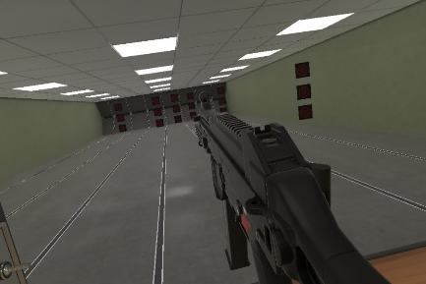
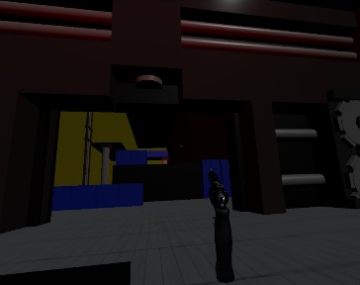
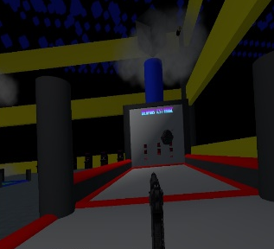
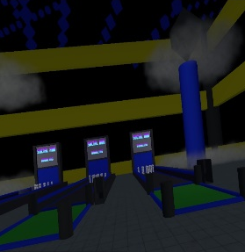
Social Sandbox VR Manual

Images of in-app to advertise concept
Android Mobile Minimum Requirements:
Current Version: 31.0
Requires Android Version: 5.0 and up (Android Lollipop)
The Android mobile version of the application will be controllable by touch-screen input and touch-screen, virtual joystick input when fully integrated, with the ability to switch between touch input mode and Google Cardboard VR mode at will to change up the player experience and game play.
PC Minimum Requirements:
Current Version: 31.0
Processor: Intel Core i5-4590/AMD FX 8350 or better
GPU: NVIDIA GeForce GTX 970, AMD Radeon R9 290 or better
RAM: 4 GB RAM or more
Operating System: Windows 7 SP1, Windows 8.1 or later, Windows 10
The Windows PC (and HTC Vive) version of the application will be controllable by keyboard/mouse input and HTC Vive controller input, with the ability to switch between desktop mode and Steam VR mode at will (with the presence of a connected HTC Vive) to change up the player experience and game play.
Please note that due to the time restraints available, this application is still in Alpha stages of development. This means that whilst most of the application features have been put in, not all of these have been fully integrated and there may be unintended bugs or other unintended behaviour as with any Alpha build.
Important Disclaimer:
If you experience any sort of discomfort when using this application, please consult with a doctor or your GP before continuing to use the Social Sandbox VR.

VR game modes require HTC Vive or Google Cardboard setups.
Overview: Connect using a tablet, mobile or PC and choose whether to play in VR or not and work with others and AI in order to explore the sandbox.
This application requires internet access for the multiplayer elements to function correctly. If a connection cannot be made, please check the firewall settings to make sure these are not blocking internet access.
Social Hub: This is where a player will first load into and be able to connect with others in the same area. This is where players can choose which game mode to play together or as opponents.
Escape Room: This game mode has players working together in order to find the exit to the escape room. PC, tablet and VR players are inside the room, completing hands-on tasks to work towards the exit solution, while mobile non-VR players are controlling the cameras around the room that may be able to see things that the other players can’t. Communication is essential to win!
Run and Gun: This game mode has players working against each other to be the ultimate winner. PC, tablet and VR players are inside the room, armed with guns pitted against the mobile players who are controlling the flying drones.
Range: Practise shooting at the gun range. This is the best place for those new to VR as it can help acclimatise slower than jumping straight into the more fast-paced games. The only limitation is the amount of ammo.
Social Sandbox VR Manual

. .

